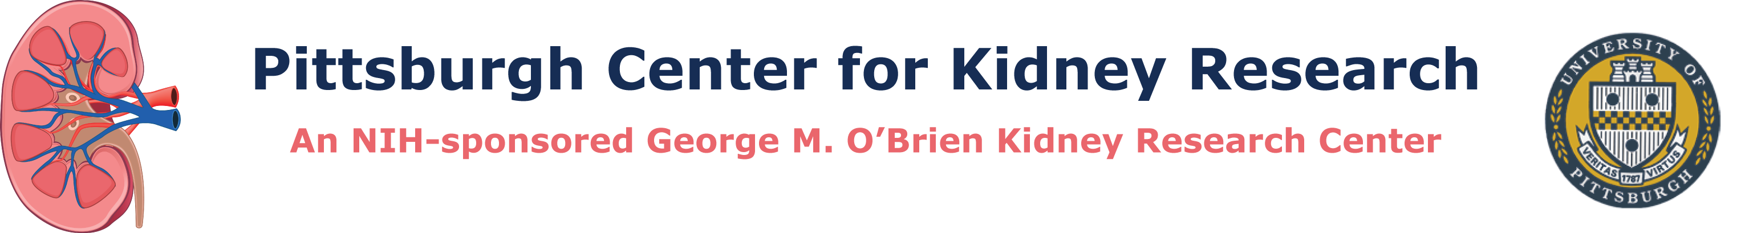
Core Use Document

To gain access to the Pittsburgh Center for Kidney Research resources, return the following by email to Dr. Thomas Kleyman (kleyman@pitt.edu) or Dr. Ora Weisz (weisz@pitt.edu):

• Completed Core Use Document

• Your NIH Biosketch

• Your NIH-style Other Support information including current and pending grant support

Principal Investigator:
Institution:
Address:

Phone:
Fax:
Email:

Using “Xs,” Indicate below the Core resources being requested:

__ CORE A: Physiology and Model Systems Core

__ 1. Microdissection and/or microperfusion of isolated tubules: Measurement of rates of ion transport; Fluorescent functional imaging (pH, intracellular Ca2+, Na/K/Cl ions) to assess live cell function
__ 2. Single isolated tubule real-time PCR, immunoblotting, immunolabeling and/or enzyme/transporter assays
__ 3. Electrophysiologic and functional expression assays of channels and membrane protein in single cell expression system (Xenopus oocytes, HEK cells)
__ 4. Electrophysiologic and functional expression assays in organized epithelia (voltage clamp measurements of short-circuit current, TER, capacitance, impedance)
__ 5. Analysis of post-translational modifications of transporters and associated proteins
__ 6. Analysis of protein folding, transit through the secretory pathway, cell surface delivery.
__ 7. Quantitative and qualitative PCR analysis
__ 8. Yeast expression systems for wild type and disease-causing versions of proteins.
__ 9. Functional in vitro assays using yeast derived factors
__ 10. Establish kidney expressing transgenic zebrafish reporter lines for small molecule genetic screens, targeted gene expression studies
__ 11. Use of chemical modulation to relieve cellular stresses and promote repair
__ 12. Assist with design, synthesis, and characterization of novel chemical compounds including evaluation of efficacy in yeast, zebrafish, and organoid model systems

__ CORE B: Animal and Translational Core

__ 1. Analysis of kidney function including RBF, GFR, electrolyte excretion, as well as analysis of markers of kidney injury, fibrosis, and inflammation.
__ 2. Analysis of cardiovascular function including measurements of acute blood pressure, chronic blood pressure, and cardiac function.
__ 3. Measurements of sympathetic nervous system function including renal nerve recordings, bladder afferent/efferent nerve activity, optogenetic/chemogenetic manipulation of renal nerve function, assessments of renal sympathetic neurotransmission, and measures of neurotransmitter release.
__ 4. Renal metabolomics including analysis of purine metabolomics, biomarkers, as well drug development and pharmacokinetics.
__ 5. HPLC determination of energy molecules and mitochondrial function.
__ 6. Animal models of kidney injury (including AKI) and hypertension and metabolic syndromes.

__ CORE C: Kidney Imaging Core

__ 1. Preparation, storage, and analysis of fixed kidney and bladder-associated epithelial cells and tissues, including imaging capture modalities (brightfield, DIC, darkfield, confocal) and image analysis (e.g., colocalization and 3D reconstruction)
__ 2. Stereological measurements and 3D reconstruction of organelles, cells, tissues, and organs.
__ 3. Fine structure analysis, immunoEM localization, scanning electron microscopy, ultrathin cyroelectron microscopy, freeze-fracture microscopy
__ 4. Super-resolution light imaging using STED and STORM technologies.
__ 5. Live cell/tissue/organ imaging using ultrafast confocal, TIRF, and two-photon microscopy.
__ 6. Access to validated antibody collection

__ Request for hands-on training, or for undertaking a formal mini-sabbatical:

__ Training/Mini-Sabbatical request for CORE A __ , CORE B __ , CORE C __ .

Provide a brief summary of the goal of the project and your proposed studies for which you are requesting use of the Center resources. Please include a description of the relevance to kidney or urologic diseases, epithelial cell biology, or physiology:

If requesting a mini-sabbatical, describe your goals of the sabbatical:

